Nexus Repository Manager Installation Process

Step 1:-

Download Nexus Repository Manager latest version from below given link

Link:- <https://help.sonatype.com/repomanager3/download>

Step 2:-

Installation Method guid link

Link:- <https://help.sonatype.com/repomanager3/installation/installation-methods>

Path:-C:\Program Files\nexus-3.32.0\nexus-3.32.0-03\bin

Command :- *nexus.exe /run*

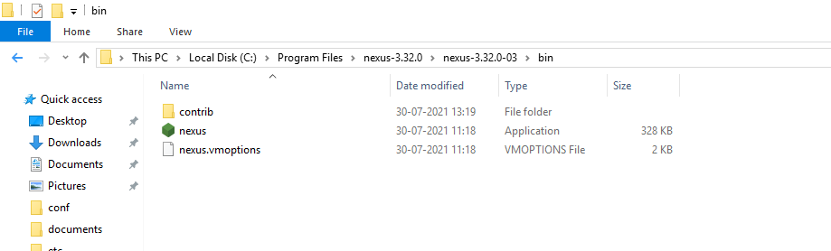

Step 3:- Nexus by default running on port no:-8081

Default ID=admin and temporary password generated at below path

Path:- C:\Program Files\nexus-3.32.0\sonatype-work\nexus3\admin.password

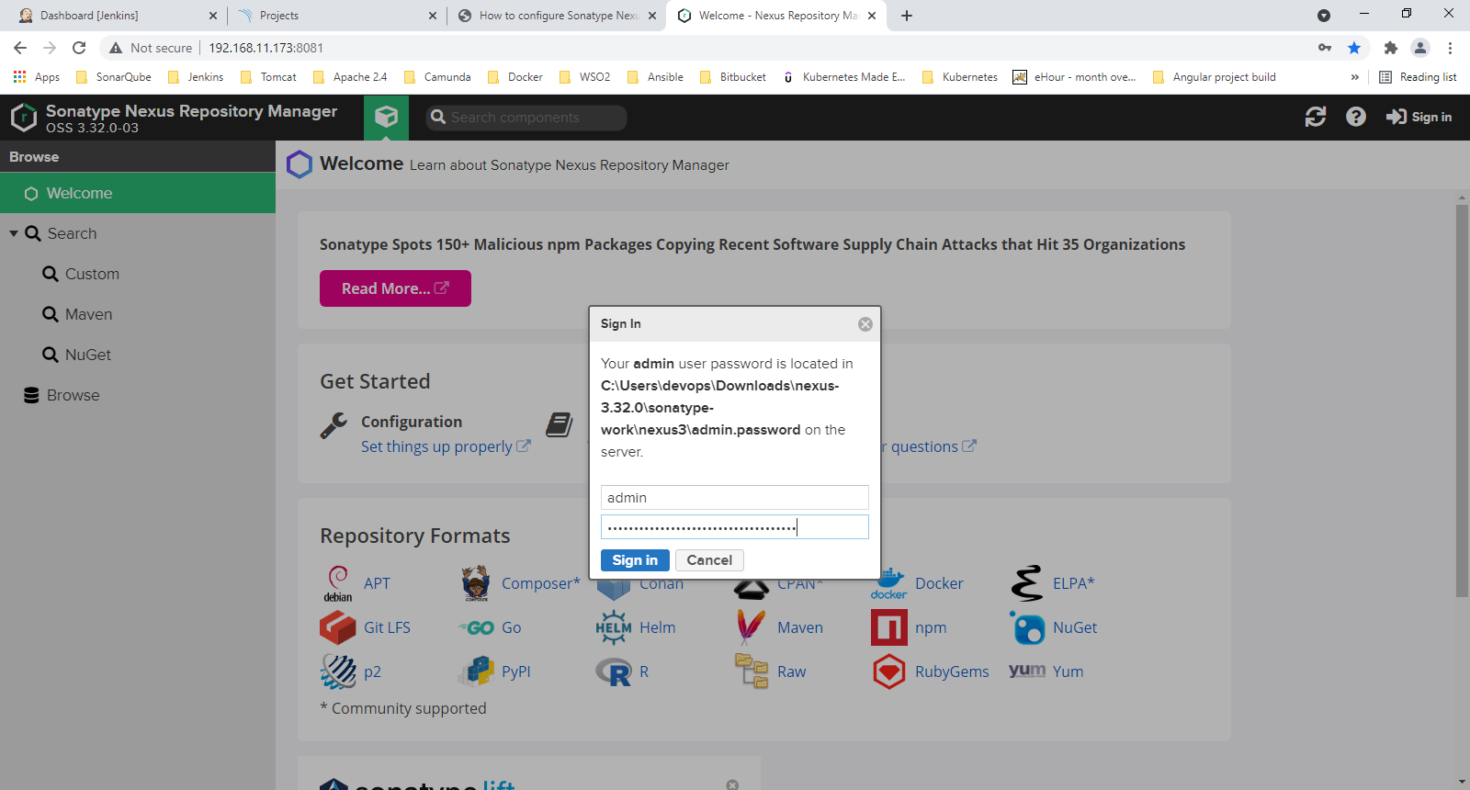

Then you need to change password.

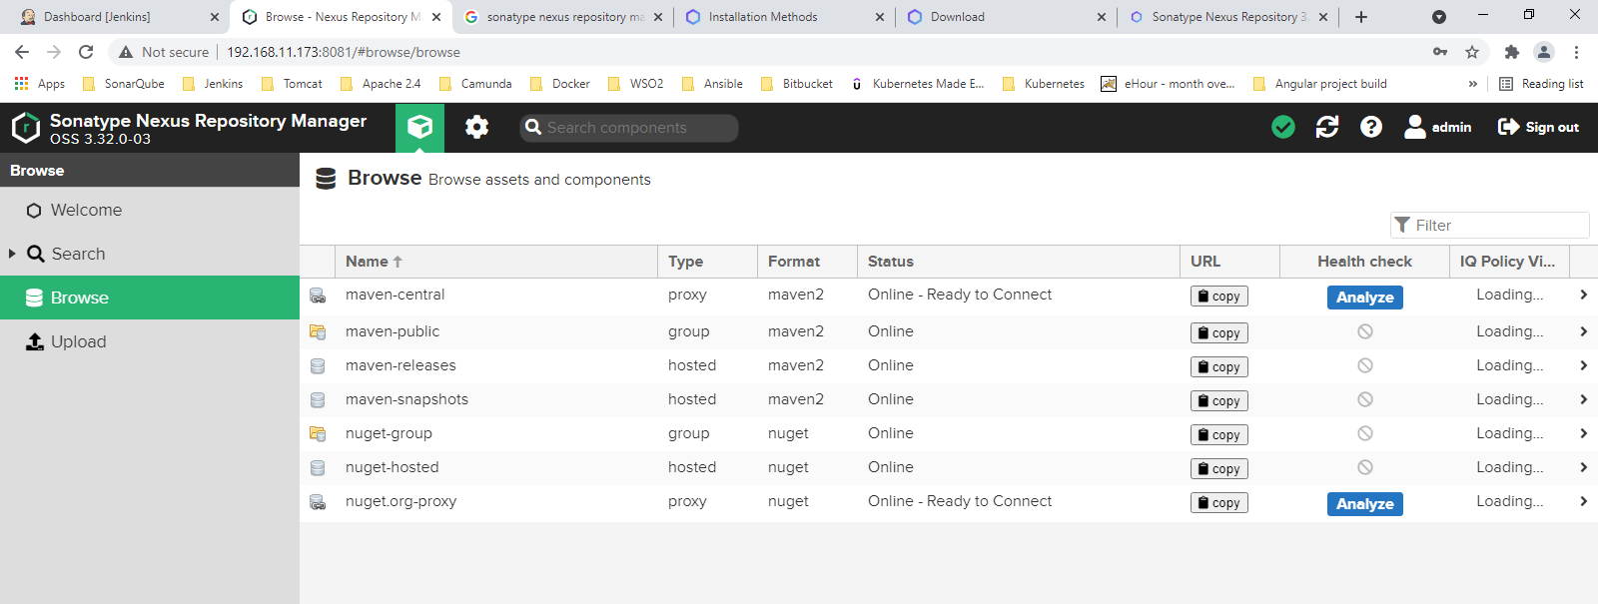

Repository Formats:-APK,APT,MAVEN etc.

Link:- <https://www.youtube.com/watch?v=vcAyOiI97AU>

Link:- <https://blog.sonatype.com/using-nexus-3-as-your-repository-part-1-maven-artifacts>

Step 4:- Each repositories has types

HOSTED:- -Read -Write Located nearest place from where you download and upload.

PROXY:- -Read Only From remote repository. Keep cache copy of it.

GROUP:- Multiple Hosted and Multiple proxy can be grouped together.

Maven Hosted Repositories:-

RELEASE

URL:-http://192.168.11.173:8081/repository/Test-Release/

SNAPSHOT

URL:-http://192.168.11.173:8081/repository/Test-Snapshot/

Maven Proxy Repositories:-

<https://repo.maven.apache.org>

URL:- http://192.168.11.173:8081/repository/Test-Proxy/

Maven Group:-

URL:- http://192.168.11.173:8081/repository/Test-Group/

Step 5:- Create Nexus Repository Role and user:-

Role and ID as **Devops**

Prevelieges as **nx-all**

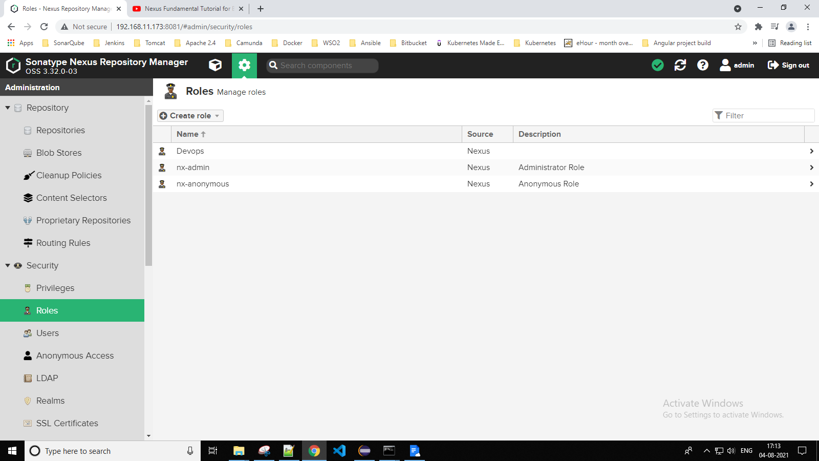

Create user as **DevopsUser** and create password as **Nucsoft@2021**

And assign role as **Devops**

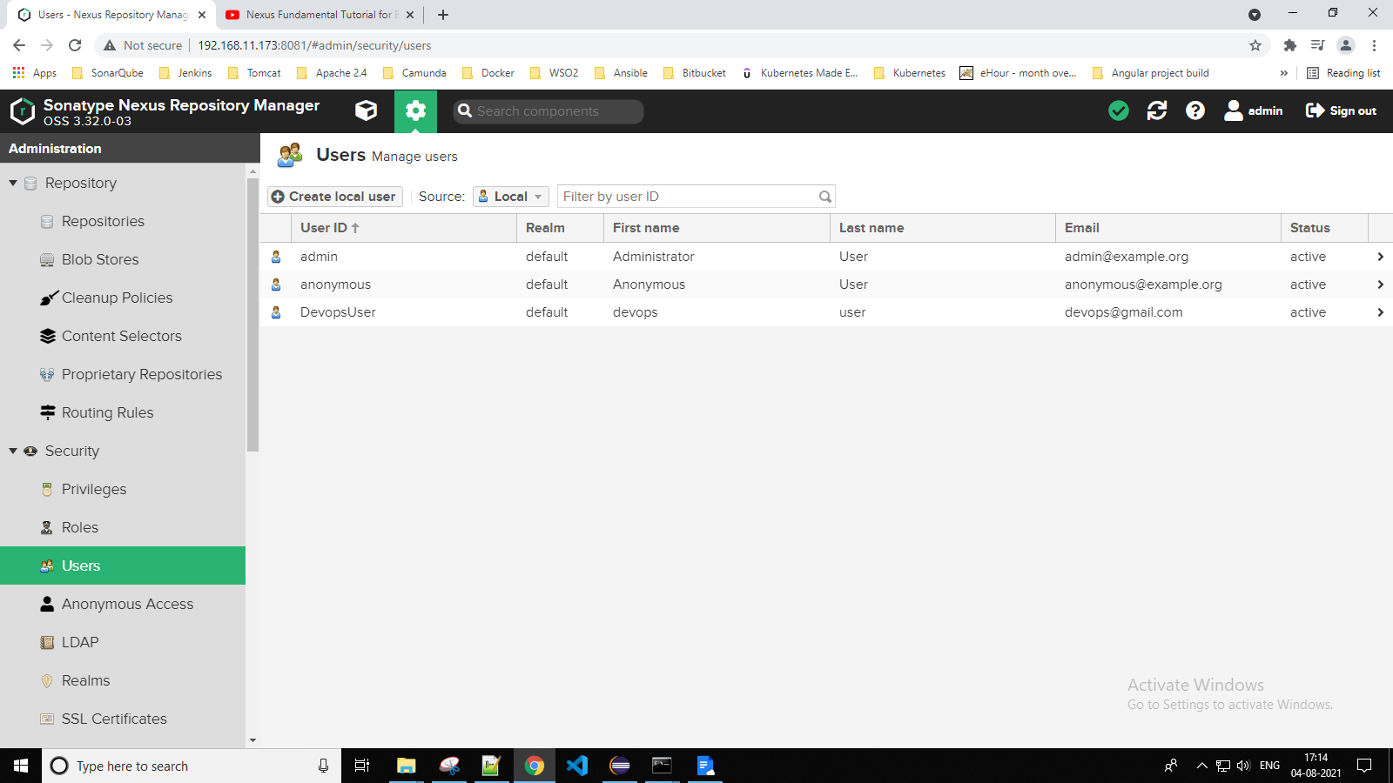

Step 6:- How to upload a artifact to nexus using maven

* Modify pom.xml with repositories location

Add below code between <project> … </project>

*<distributionManagement>*

*<repository>*

*<id>nexus</id>* ***//id must match with settings.xml id***

*<name>release softx</name>*

*<url>http://192.168.11.173:8081/repository/Test-Release/</url>*

*</repository>*

*<snapshotRepository>*

*<id>nexus</id>*

*<name>snapshot softx</name>*

*<url>http://192.168.11.173:8081/repository/Test-Snapshot/</url>*

*</snapshotRepository>*

*</distributionManagement>*

* Modify setting.xml with permisssion

Add below code between <servers> … </servers>

*<server>*

*<id>nexus</id>*

*<username>DevopsUser</username>*

*<password>Nucsoft@2021</password>*

*</server>*

* Use below command to execute maven build

Command :- *mvn deploy*

Step 7:- How to download a artifact from nexus using maven

* Modify pom.xml with dependant library which you want to download

Add below code between <project> … </project>

*<distributionManagement>*

*<repository>*

*<id>nexus</id>* ***//id must match with settings.xml id***

*<name>release softx</name>*

*<url>http://192.168.11.173:8081/repository/Test-Release/</url>*

*</repository>*

*<snapshotRepository>*

*<id>nexus</id>*

*<name>snapshot softx</name>*

*<url>http://192.168.11.173:8081/repository/Test-Snapshot/</url>*

*</snapshotRepository>*

*</distributionManagement>*

*<repositories>*

*<repository>*

*<id>nexus</id>*

*<name>release softx</name>*

*<url>http://192.168.11.173:8081/repository/Test-Group/</url>*

*</repository>*

*</repositories>*

*<pluginRepositories>*

*<pluginRepository>*

*<id>maven2</id>*

*<url>https://repo.maven.apache.org/</url>*

*</pluginRepository>*

*</pluginRepositories>*

* Modify setting.xml with mirrors

Add below code between <mirrors> … </mirrors>

*<mirror>*

*<id>nexus</id>*

*<name>nexus</name>*

*<url>http://192.168.11.173:8081/repository/Test-Group/</url>*

*<mirrorOf>*</mirrorOf>*

*</mirror>*

* Use below command to execute maven build

*mvn deploy | compile | test | install*